The Sustainability Balanced Scorecard – linking sustainability to corporate strategy.

Vikas Gupta and Meenu Chopra
Dr. Vikas Gupta, Assistant Professor, Delhi School of Management, Delhi Technological University, vikasguptadtu@gmail.com
Meenu Chopra, Research Scholar, Delhi School of Management, Delhi Technological University, mchopra2002@gmail.com

Abstract:
Balanced Scorecard given by Kaplan and Norton is a management tool that aims to support the successful implementation of corporate strategy. It has been widely researched and discussed in the corporate circles. By the process of linking non-financial, operational day to day activities and establishing causal relationship chains to the firm’s long-term strategy, Balanced Scorecard helps in aligning these corporate activities according to their strategic value. Corporate houses must function as the major driver of innovation and sustainability in our society. We are faced with resource scarcity, climate change and pollution and their effects are already starting to show up. The inclusion of social and environmental concept along with financial performance as a measure of organizational success is a response to this need. The paper aims to develop an understanding of a strategy based balanced scorecard system aligned with these principles in order to accomplish social and environmental goals while integrating them fully with financial performance and competitiveness.
Keywords: Sustainability balanced Scorecard (SBSC), Corporate Strategy, and Sustainable development
1. Introduction
Harvard Business Review, in a recent article, said that Sustainability imperative is a game-changing business trend and compared it with other megatrends of the past like rising of the quality movement, the introduction of the personal computer, and the internet. Such trends have known to affect the competitiveness and even the survival of business organizations. While economic scarcities are easily reflected in business transactions, environmental and social scarcities are only partially seen. With the growing importance of these aspects in business, companies are implementing specific environmental and social management systems. These systems are, however, not integrated with the general management of the firm. As a result, this aspect still remains neglected. The decisive role of companies in achieving sustainability has been stressed and discussed on the strategic and instrumental level. If organizations have to achieve improvements on the three major thrust areas of sustainability i.e. economic, environmental and social, a mechanism to integrate the various parameters has to be developed. The balanced scorecard as a strategic management tool helps to identify strategically relevant issues in a business. The cause and effect relationships understood by the use of balanced scorecard contribute to the successful achievement of a firm’s strategy (Kaplan and Norton, 1997). Thus it seems logical to use the balanced scorecard methodology as a tool to integrate environmental and social management of a firm. With this aspect in mind, a number of authors have dealt with the topic of a Sustainability balanced scorecard (Radcliffe, 1999; Beiker et al 2001; Epstein and Wisner 2001; Epstein and Roy 2001). A value-oriented corporate sustainability management with the help of balanced scorecard helps to integrate the three pillars of sustainability into a comprehensive management tool.
This paper aims at presenting the sustainability balanced scorecard as a tool for sustainability management. First, a discussion on the concept of sustainability is provided followed an elucidation of the balanced scorecard. The next section deals with integration of the concept of sustainability in balanced scorecard making it possible for organizations to align their strategy with the said concept and develop control measures in case of any deflection.

2. The concept of Sustainability
Sustainability and Corporate social responsibility (CSR) are two closely related terms. Initially, corporate social responsibility largely referred to the social impact of business while sustainability took notice of the long-term environmental effect of human activities. Recently, the boundaries between the two have merged and increasingly, these terms are now being used interchangeably. For the purpose of this paper, sustainability will be defined in close context to the book ‘The next sustainability wave’ authored by Bob Willard where he identifies a continuum of “shades of green”. According to him, adoption of sustainability by organizations can be categorized into five stages – pre- compliance (focus is on profits, resists regulation and other pressures for sustainability), compliance – follows regulation for sustainability but still sees it as a cost), beyond compliance (strategy changes from defense to offence, realizes that cost and risk can be reduced by minimizing waste, pollution and energy use, integrated strategy (integrates sustainability with key business strategies, captures added value from breakthrough sustainability issues that add value for all stakeholders), purpose and passion (passionately committed to improvement of the society and the environment).
Organizations are seeking to develop a more comprehensive way to measure performance that includes an element of sustainability. The triple bottom line is the most popular view of performance which includes planning, managing and reporting on business results in three areas – economic, environmental and social. Despite its growing adoption, there are some limitations in the triple bottom line concept e.g. lack of focus on firm’s competitive strategy, lack of connection with the firm’s real business, treatment of social and environmental impacts as an additional activity not as a key part of business strategy and no guidance on how to achieve the desired results.
There is a clear lack of unison, a missing link between business success and sustainability.
3. The concept of Balanced Scorecard
Balanced Scorecard was developed in the early 90’s as an approach which promised to solve the problems of short-termism and past orientation existing in the earlier performance management tools (Kaplan and Norton, 1992). The balanced scorecard has proven to be one of the most successful business management ideas of the last 20 years, and has been adopted by more than half of Fortune 500 companies, and many government and nonprofit organizations as well. This concept is based on the premise that an organization’s success or failure cannot be measured only on the basis of the efficient use of investment capital. With the increasing importance being given to intangible assets like intellectual capital, balanced scorecard aimed at measuring these aspects also in order to draw a complete picture of an organization’s performance. An increased the focus on day to day activities and their alignment with corporate strategy. This approach makes the contribution of intangible assets and soft factors in the financial success of a firm explicit and more controllable.
There are six basic components of BSC.
a) Perspectives: It looks at the strategy of an organization from four perspectives – learning and growth, internal process perspective, customer satisfaction perspective and financial perspective. However, if required, organizations may decide to include more perspectives for measuring present performance and gauging drivers of future performance. All important factors for strategy execution are accounted for in these perspectives. This creates a balance between short term and long term objectives; also a link is established between desired outcomes and performance drivers to reach these outcomes.
b) Themes: They are an integral part of the strategy and provide a guiding path for the achievement of an organization’s mission. Each perspective has a set of three to four themes along with objectives which facilitate execution of the theme.
c) Objectives: These must be achieved as they are critical to the success of the organization.
d) Measures: Measures help an organization determine its success in implementing the strategy.
e) Targets: They help in understanding the level of performance achieved and rate of improvement needed, if any.
f) Strategic initiatives: These are the action programs to be undertaken.

The BSC’s four perspectives can be briefly described as follows (Kaplan and Norton 1997)
- Learning and growth – It identifies important areas like availability of the right infrastructure, qualification and skill set of the employees which are essential for the achievement of the other three perspectives.
- Internal process perspective – It identifies those internal business processes which enable the firm to deliver value to its stakeholders.
- Customer perspective – It refers to the market segment in which the organization wishes to achieve a competitive edge.
- Financial perspective – It indicates the financial performance a strategy is expected to achieve on one end and on the other it is the last leg of the cause and effect chain established by the BSC.

Balanced scorecard is different from other performance management tools as it establishes a cause and effect relationship between the measures across the four perspectives. It explains strategy as a set of cause and effect relationships e.g. it can be hypothesized that if an organization has good learning and growth programs, the internal processes will be more efficient leading to better customer satisfaction and hence customer retention; customer retention will lead to better financial performance of the firm. These causal relationships help predict the financial performance of an organization based on non-financial indicators.

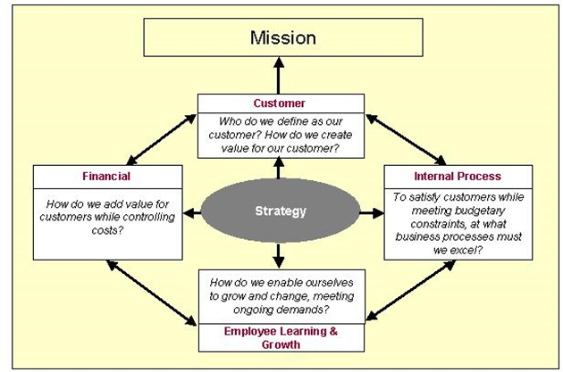
Figure 1 – Four perspectives of the Balanced Scorecard
Source: Source: Zaribaf and Samandi, IJGMS Volume 2 Issue 2
3.1 Strategy map
A pictorial representation of objectives across four perspectives of BSC, with the connectors showing the cause and effect relationship between them is called a strategy map. A strategy map helps to communicate strategy in only one page and also provide a framework for testing assumptions about the strategy. It is built by first listing perspectives, followed by defining themes, setting objectives and building causal linkages among objectives. Financial perspective shows how strategy balances long term with short term objectives. Customer perspective depicts the differentiated value proposition the organization wishes to offer to the target customer. Internal process perspective fulfills two components of strategy – production and delivery of the value proposition to the customers and improvement in processes and reduction of costs for the production component in the financial perspective. Learning and growth help in aligning the intangible assets with organization’s strategy.
4. Sustainability and Balanced scorecard
Sustainability should be woven in creating the themes during the process of strategy formulation. By creating a strong focus on sustainability, every process in the organization will be aligned to achieve it. Development of more eco-friendly products, partnering with regulators more effectively, and reduction in the life cycle impact of firm’s operations, building new technology to decrease and offset the effects of previous not so efficient methods can become a part and parcel of a firm’s day to day practices. ‘Sustainability metrics’ generally are internal processes though in some cases may also support branding exercises in the customer and stakeholder perspectives e.g. greenhouse gas emissions, electricity and water usage, industrial waste generation.
Measurement based balanced scorecards are simple performance measures categorized under different heads that are of interest to the immediate manager. These scorecards generally report on operational measures and give no information about ‘how an organization creates value for its customers’. On the other hand, a strategic performance scorecard system is an organization-wide tool which integrates strategic planning, management, and measurement at the same time. Building a strategy based scorecard planning and management system is similar to building a customized product for a customer. Before the tool is created, the organization will ask itself, ‘Am I doing the right thing?’ – the operations, processes and tactical question follow next. ‘Are we doing things right?’ Strategic themes support the organizations and help in the achievement of business mission and vision. All the themes merge into a powerful and mutually reinforcing business strategy.
Strategic objectives follow next. They are the building blocks of strategic themes and put forward an action plan for employees to follow. These objectives are linked together to form a strategy map. A strategy map is built for each theme and it depicts cause and effect links among strategic objectives across the four perspectives. In a strategy based balanced scorecard system, measures are a means to achieve ends, not ends themselves like performance measurement is a process and not a one-time event. The process of setting measures will only be meaningful once strategic objectives have been set and linked together on the strategy map.
5. Conclusion
The paper describes the methodology of development of the Sustainability balanced scorecard as a tool for incorporating value-oriented activities in an organization. The integration of environment and social issues with the general management of the firm sensitizes the entire organization towards the changing needs of the society. The creation of a balanced scorecard is a journey not reaching a destination. While we have clear and defined start and stop points along the path, the most important point remains that the real value of an integrated strategy based scorecard system will only be achieved from continuous self-check mechanisms and in-depth analysis which remain at the heart of every successful strategic planning and performance management system. An organization should start the process of balanced scorecard formulation with a clear thought of achieving organizational improvement in every aspect on the way.

Fig 2: Sustainability balanced scorecard

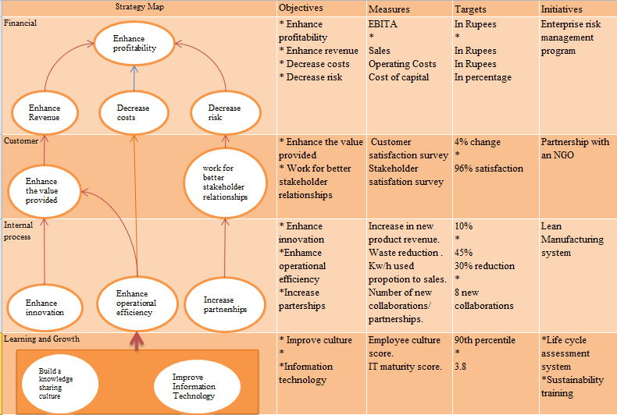
Source: Adapted from ‘Linking corporate strategy to sustainability’ Rohm, H., & Montgomery, D. (2011)
References
Beiker,T; Dyllick,T; Gminder,C.-U. & Hockets, K. (2001a): Towards a Sustainability balanced scorecard – Linking environmental and social sustainability to business strategy. Conference proceedings of business strategy and the environment 2001 in Leeds, UK. ERP environment, 22-31
Epstein, M. J., & Wisner, P. S. (2001). Using a balanced scorecard to implement sustainability.Environmental quality management, 11(2), 1-10.
Epstein, M. J., & Roy, M. J. (2001). Sustainability in action: Identifying and measuring the key performance drivers. Long range planning, 34(5), 585-604.
Figge, F., Hahn, T., Schaltegger, S., & Wagner, M. (2002). The sustainability balanced scorecard–linking sustainability management to business strategy. Business strategy and the Environment,11(5), 269-284.
Gupta, V and Chopra, M. (2016), “Knowledge Management Practices and Balanced Scorecard Outcomes – An Organizational Performance Perspective”, Conference proceedings on Changing organizations through strategic, technological, structural and behavioral interventions in GGSIPU, India, 16-27
Kaplan, R. S., & Norton, D. P. (1997). Why does business need a balanced scorecard?. Journal of cost management, 11, 5-11.
Kaplan, R.S. and Norton, D.P., (1996). The balanced scorecard: translating strategy into action. Harvard Business Press.
Kaplan, R.S. and Norton, D.P., (2004a). Measuring the strategic readiness of intangible assets. Harvard business review, 82(2), pp.52-63.
Kaplan, R.S. and Norton, D.P., (2004b). Strategy maps: Converting intangible assets into tangible outcomes. Harvard Business Press.
Kaplan R. S., & Norton D. P. (1992) “The balanced scorecard – measures that drive performance”, Harvard Business Review, 70(1), 71–79
M. Punniyamoorthy R. Murali, (2008), “Balanced Score for the Balanced Scorecard: a benchmarking tool”, Benchmarking: An international Journal, Vol 15 Iss 4 p.p. 420-443
Radcliffe, M. (1999, November). Using the Balanced Scorecard to develop metrics for Sustainable Development. In Conference Proceedings of Greening of Industry Network.
Rohm, H., & Montgomery, D. (2011). Link sustainability to corporate strategy using the balanced scorecard. Online at http://www.Balanced scorecard.org/Portals/0/PDF/Linking Sustainability to Corporate Strategy Using the Balanced Scorecard. pdf.
Zaribaf, M. and Samandi, B. (2010), “Balanced Scorecard and Determining the relation of strategic goals and performance measures: Evidence, Semnan Province tax organizations of Iran”, International Journal of Global Management Studies, Vol 2 Iss 2, pp.67-93

