Welcome to the workbook for the Massive Open Online Course Community Engagement: Collaboration for Change.
Please make a copy of this document for your personal use. (file-->make a copy) and save it to your own google drive.
If you experience difficulty copying or accessing your copy, please email CollabForChangeMOOC@umich.edu
TABLE OF CONTENTS

CCEE-1 Entering the Community 2
CCEE-2 Flexibility & Failure 4
CCEE-3 Motivation and Values 5
SIPP-1 What are Social Identities? 6
SIPP-2 Dimensions of Social Identity (continued) 8
SIPP-3 Recognizing Power in Your Life 9
SIPP-4 Collaboration, Coalition, and Partnerships 10
SIPP-5 Identifying privileges 11
CL-1 Identifying Your Partnership 14
CL-2 Part 1: Evan’s Community Engagement Experience 15
CL-3 Part 2: Evan’s Community Engagement Experience 15
CL-4 Roadblocks to Listening 16
CL-5 Part 3: Evan’s Community Engagement Experience 16
CL-6 Strategies for Adapting to Change 17
CL-8 Managing Group Conflict 18
RT-1 Easy Reflective Framework 19
RT-2 Self-Care Strategies 20
RT-3 Cultural Transitions: Exiting the Community 21
RT-4 Your Experience, Your Story 22
PM-1 Crafting an Opportunity Statement 23
PM-2 Developing Objectives 24
PM-3 Identifying Deliverables 24
PM-4 Stakeholder Discovery 26
PM-5 Stakeholder Discovery II: Identifying Stakeholders 26
PM-6 Specifying Exclusions & Assumptions 27
PM-7 Managing Time 27
PM-8 Ensuring Sustainability 28
C-1 Parting Insights 29
C-2 Integrative Reflection 30

CCEE-1 Entering the Community
For this activity, you will be asked to reflect on your own personal experiences. Take a moment to set aside anything that might be distracting you and make yourself comfortable.
To begin this activity, picture a space that’s just yours. This could be your bedroom, your work space, or even your kitchen. Picture the space clearly - you can even use the space below to draw a sketch or write a description of it, highlighting the elements that are most important to you.
Once you have conjured a clear picture of your space, imagine someone comes in while you are sitting there. This isn’t someone you have met before and the first thing you notice about them is that they are carrying a clipboard. Without acknowledging your presence, they begin taking notes and commenting aloud about their opinion on the space and how it’s being used. They might start offering suggestions on how you can use your space better: orient your bed differently, re organize your bookshelf, move your plants closer to the window. They even begin looking at the framed pictures on your shelf and commenting on the people in them, wondering if these are really the best pictures to display. They do not stop to ask your opinion or look at you to see if you are interested in their opinion.
What would your first response be if this happened? How would you react if someone came into your space, and expected you to tell them the details of your life-- the happy ones, the challenging ones, the embarrassing ones? How did that make you feel?

Would their motivation for acting this way matter to you? For example, would it make you feel differently if they said they were there to help, that they just wanted make sure you made the best use of your space and only had your best interests at heart

Chances are, your reaction to this unsolicited visitor wasn’t very positive, regardless of the motivation behind their actions. If you have this understandable reaction to someone coming into our space, how might community members feel as you enter their spaces?

This example might seem exaggerated, but it is actually not too different from what often takes place when students or researchers enter communities. While community engagement requires you to know important details about the history, relationships, and culture of a community, how you learn, and use this information, is critical. The ways you develop relationships with members will shape not only what information is shared with you, but also how useful it will be to you. Community members may need to know that you are invested in your relationship before giving you the important information you want to know.
This activity is based on a training entitled Entering, Engaging, and Exiting Communities, developed by The Edward Ginsberg Center at the University of Michigan.
CCEE-2 Flexibility & Failure
You probably have a lot of thoughts going through your head over the course of this module -- that’s good! The purpose of this module is to get you thinking about community engagement in new, more mindful ways.
Take a minute to reflect on how the information in this module (Ernesto Sirolli’s talk, the articles you read, and student videos) has changed the way that you think about community engagement. Next, write a brief 4-5 sentence reflection in your notebook related to the questions below.

Reflection Prompts
Think about a time when you did something that didn’t go as planned because you didn’t ask the right questions. The situation does not necessarily need to be related to community engagement.
- How could you have avoided the outcome?
- If you could go back and change the way you handled the situation, what would you do differently?
- What did you learn from the experience?
Now, write down one key takeaway from your reflection that you want to remember as you prepare for future community engagement work.

CCEE-3 Motivation and Values
In the following video clip listen as Barbara discusses the importance of developing project specific principles for community based work.
Video: Donele & Barbara’s Video [35:52-37:07]
Now it is time to reflect on your own motivations and develop your own ethical principles or guiding values.
First, take a minute to reflect on what motivates you to do community engagement work. What values or beliefs bring you to this work? Do you want to help? Make change? Learn? Give back? Take a few minutes to record 3-8 things that motivate you to get involved in community engaged projects.

Next, take a few minutes to review the different principles and guidelines introduced in this module including the Principles for Community and Civic Engagement, the Core Principles of Public Engagement, and the Oath for Compassionate Helpers. What connections do you see between your motivations and the principles that guide ethical work? What differences do you see? Spend some time reflecting on similarities and differences.

Lastly, take some time to jot down 3-8 principles or values that you are committed to following when engaging in community work.

SIPP-1 What are Social Identities?
All of us have multiple social identities. What are your Identities?
Before you dive into the activity below, take a few minutes to close your eyes and reflect. What kind of groups do you belong to? What springs immediately to mind? Is it easy or difficult to generate a list of your social identities?

No one else will see your responses, so you can answer honestly. For each category listed in the identity wheel, write the term (or terms) you identify with. We have provided examples for each category, but these are not exhaustive.

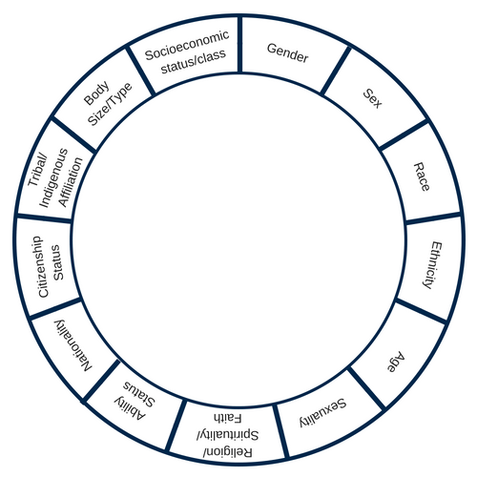

Identity Category Examples
(Feel free to use your own language for your identities. These examples are not exhaustive)

Gender | Woman, boy, trans, non-binary, femme
Sex | Intersex, female, assigned male at birth
Race | Asian Pacific Islander, Native American, Latinx, Black, White, Bi/Multiracial
Ethnicity | Puerto Rican, Irish Catholic, Igbo, Sunni, Chinese, Italian, Mohawk, Guatemalan, Scots-Irish, Lebanese, European-American
Sexuality | Questioning, Asexual, Gay
Religion/Spirituality/ Faith/Meaning | Hindu, Muslim, Buddhist, Jewish, Christian, Pagan, Agnostic, Atheist, Secular Humanist
Socio-Economic Class | Poor, Working Class, Lower-Middle Class, Upper-Middle Class
Age | Child, Young Adult, Middle-Age Adult, Elderly
Ability and Accessibility | People with disabilities (cognitive, physical, emotional, etc.), Temporarily able-bodied, Temporarily disabled
Nation(s) of Origin | United States, Nigeria, Korea, Turkey, Argentina
Citizenship Status | Citizen, Permanent Resident, Undocumented
Tribal/ Indigenous Affiliation | Mohawk, Aboriginal, Navajo, Santal
Body Size/ Type | Fat, Person of Size, Thin, Tall, Short

SIPP-2 Dimensions of Social Identity, continued
In her narrative, Candace described the way being in Ecuador made her more aware of her American identity. Now it's your turn to imagine what aspects of your identity you are more or less aware of in different settings. You may want to reference the social identity wheel you completed in the last activity,
Using the identity categories provided, indicate which identities you think about most or least based on the prompts in your workbook.
- Ability status:
- Body type
- Social Class/Socio-economic status
- Race
- Ethnicity
- Sex
- Gender
- Sexuality
- Religion/Spirituality
- Age
- First Language
- Citizenship
- Education
I think about _____ identities the most…; I think about _______ identities the least
In class or learning spaces | In extracurricular activities or clubs
In your local grocery store | When traveling
In service experiences | When meeting someone new
SIPP-3 Recognizing Power in Your Life
Where do I get my power from?
In this activity you will be reflecting on the sources of your power. You may want to grab some markers or colored pencils as you will be sketching to start this activity.
Create a sketch of yourself using images and words to show where you get your power from. You should interpret the question as you wish – literally, figuratively or both.
A few questions to ask yourself as you sketch:
- How do I cope with difficulties and challenges?
- What makes me feel good about myself?
- What are my support systems?
- In what scenarios do I feel the most or the least in control?

To help you get started, consider the sketch made by Jesse, describing the different sources of power in his life.


Once you have finished your picture, take a minute to ask yourself:
- Which bases of power are represented in your picture? Which are absent?
- In what way are your social identities present in your sketch?
  - Which of your identities are visible? Which are absent?
  - For each source of power present, ask yourself how, if at all, it is related to your social identities. For example, if you get power from your education, what different facets of your identity does that relate to?

SIPP-4 Collaboration, Coalition, and Partnerships

Throughout this course you have been reflecting on three Principles for Community and Civic Engagement.
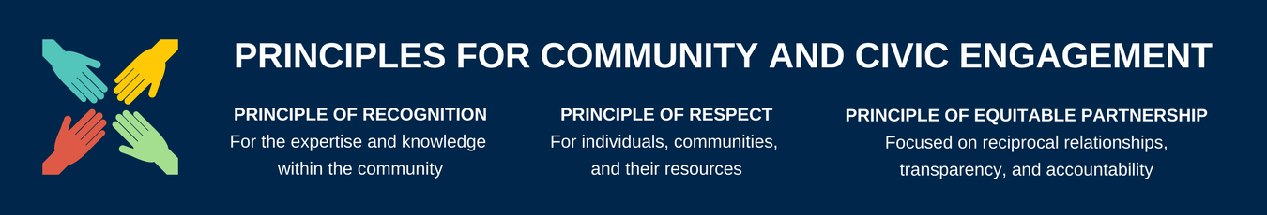

Answer the following questions:
- How can you put these principles into practice through solidarity and coalition based on what you’ve learned so far in this module?
- What is the role of recognition in diverse coalitions? What aspects of identity and power need to be recognized or acknowledge in order to create an effective partnership, according to what you’ve learned in this module?
- What does respect look like when it comes to social identities and power? How do you practice respect amidst social difference and power inequities?
- What does equitable partnership involve when you are bringing together diverse groups of people operating with different kinds and amounts of social power?

SIPP-5 Identifying privileges

Below is a list of privileges awarded to different dominant or advantaged groups. For the purposes of this activity, imagine you exist in a world without these privileges. Each privilege listed is for sale for $100 each. With a budget of $500, determine how you would spend your money.
I can…
- arrange to be in the company of people with the same social identity with relative ease.
- rent or purchase housing that is accessible to me in an area which I can afford and in which I would want to live.
- go shopping, pretty well assured that I will not be followed or harassed because of my social identities.
- learn about the history, literature, and culture of people who share my social identities without taking a specialized course
- find staple foods that fit with my cultural traditions at grocery stores, hear the music in my first language on the radio, go into a hairdresser’s shop and find someone who can cut my hair, buy clothing that fits my body in most major retailers.
- protect my children most of the time from people who might not like them, and raise them without fearing state intervention
- be assured that I won’t be asked to speak for all people who share one of my social identities.
- access government assistance if I am unemployed or cannot afford to feed my family.
- obtain a driver’s license or state identification easily.
- travel freely through different spaces on foot, public transit, car, or plane without attracting negative attention from residents or law enforcement due to my social identities.
- go home from most meetings of organizations I belong to feeling somewhat tied in, rather than isolated, out-of-place, outnumbered, unheard, held at a distance, or feared because of my social identities.
- obtain quality medical care if I am hurt or sick and be confident that medical professionals will not doubt what I tell them about my pain or illness because of my social identities
- access public buildings, parks, restaurants easily by the main entrance, and will never be forced to go around a back entrance or denied entrance to the building while others pour freely in and out of the main entrance.
- get hired for a job without people assuming I was chosen based on my social identity rather than my skills.
- celebrate religious and culture events without fear, expect to have time off work to celebrate and won’t be pressured to celebrate holidays from another faith or culture that may conflict with my values.
- be confident that if I am being tried in court the majority of the jury of “my peers” will share many or most of your social identities.

- travel to any part of the country and know my beliefs and values will be accepted, safe, and that I will have access to spaces to practice them.

A few questions to ask yourself:
- What was this process like? Did you find it easy or difficult to narrow down your top priorities?
- Which, if any, of these privileges were you conscious of before working through the checklist?
- Imagine your budget doubled in size. What privileges would you add and why?
- What if you could only choose one privilege - what is most important to you and why

CL-1 Identifying Your Partnership

 | Leading an Existing Project | Participating in an Existing Project | Starting Something New
Scenario
Partnership Building Roles

Think about your own community engagement experience in the context of this chart. Reflect on the following questions:
- What do you anticipate your role to be?

- What do you anticipate the role of the community to be?

- Will both you and community members have a number of different roles in the project?

- How will you react if you enter the community anticipating that you will be undertaking one role, and they have expectations that you will be acting in a different capacity?

- If you are unsure of what the roles between you and your local counterparts will be, what are some strategies you can take to investigate this?

CL-2 Part 1: Evan’s Community Engagement Experience
Take a minute to reflect on Evan’s role within the community partnership. What would you do if you were Evan? Write a plan that includes the action steps you would take if you were in Evan’s position.

CL-3 Part 2: Evan’s Community Engagement Experience
What do you think of Evan’s new approach to collaborating with the community? What did she do well and what should she have done differently? How did her actions compare to your action plan?

CL-4 Roadblocks to Listening
As part of the Community Context & Ethical Engagement module, we asked you to view a Ted Talk by Ernesto Sirolli about his experience with community engagement. If you have not yet viewed this Ted Talk, please take a moment to view it.
Pick a listening style discussed in this module (active, reflective or generative) and write in your workbook how you think it could have helped Mr. Sirolli and his team avoid the hippo fiasco. Do you think that Mr. Sirolli encountered any of the roadblocks to listening in his experience in Zambia? If so, which ones?
Have you ever experienced one of these roadblocks while practicing listening skills? Which roadblocks do you think you come up against the most? Why? Now that you are more aware of these roadblocks, how will you modify your listening style to avoid them?

CL-5 Part 3: Evan’s Community Engagement Experience
In your workbook, write a reflection about the role that adaptability and flexibility will play in your community experience. Can you anticipate any situations similar to Evan’s that might arise in your experience? How will you work in partnership with the community to overcome any challenges?

CL-6 Strategies for Adapting to Change

Reflect on the following questions:
- How can you incorporate these 4 strategies into your own community engagement experience?
- What strategy do you think will be most difficult to use?
- How can you challenge yourself to intentionally practice it when engaging in the community?

CL-7 Understanding your approach to Conflict
Reflect on the following questions:
- Were you the animal that you thought you were?
- Did the results of the conflict style quiz surprise you?
- Do you think your conflict style may change depending on the circumstance?
- How will knowing your approach to conflict help you during your community engagement experience?
- Think of one or two pros and cons for your conflict style. Why might others favor a different approach?

CL-8 Managing Group Conflict
Pick two approaches from the conflict styles chart and analyze how the conflict Janelle and her group members experienced could have looked different if they utilized these approaches. Map out the possible outcomes for the conflict reflecting on how things could have gone differently based on the approaches you selected.

RT-1 Easy Reflective Framework

Now, let’s take a minute to practice reflection based on an experience you have had in everyday life. Select one of the following three prompts and work through the following reflective framework.
- Remember the time when you met your roommates or hall mates at your college or university.
- Consider the first time you did something, perhaps visiting a new country or trying a new sport.
- Think about a recent customer service experience you had.
What?  Briefly recount where you were, who you interacted with, where did the interaction take place. Do you remember your fears and expectations? Describe them. | So What?  Do you remember any conflicts that arose? Perhaps from not knowing but needing to live with a new person(s). Now explain how that particular situation made you feel, whether anything surprised or intrigued you about the person, and whether anything surprised or intrigued you about your own actions in the situation.
Now What?  In hindsight, does the conflict and your actions/reactions surprise you?  Finally, reviewing your prior responses, note what you might do similarly or differently in future experiences as a result. | What else?  What are you still unsure about or confused about? What do you want to think more about or do more research on?
Reflection on the reflection:
How did the act of diving deeper into a recent customer service experience affect your memory of that experience or your future action.

RT-2 Self-Care Strategies

To help you begin thinking about self-care proactively, this activity asks you to think about what self-care strategies you’re already using, what new ones interest you, and ways to modify an activity to fit the setting you’re in.
Read through the list below. In the empty box on the right, use the following symbols to note whether or not each option is a good fit for you. There are empty rows at the bottom so you can fill in any tactics that aren’t included on the list.



Check: I’ve done this before Heart: This is my favorite or go to self-care strategy


Star: I do this currently Circle: I’m interested in trying this

Strategy | Tried it? | Modifications & Adaptations
Meditation or sitting in a quiet space
Clean up your space |  | do
Deep breathing exercises |  | do
Listen to music |  | do
Movement, such as yoga, running, cycling, or walking |  | Need to do more often.
Take some “me time” |  | do
Art making - painting, making music, knitting, or even coloring |  | Neet to try.
Spend time with close friends |  | do.
Unplug for an evening |  | tried.
Play - board games, sudoku, a game of catch |  | Need to engage in play.
Reading for pleasure
Break your routine - go somewhere new or even just taking a different route to work or the grocery store |  | Need to try this.

Once you’ve gone through the list, select self-care tactics you hope to use during your community engagement experience. Make sure at least one of them is something new you haven’t tried. Then use the third column (or space below) to make note of some ways you could modify the activity to suit different settings. For example, maybe your favorite form of self-care is shooting hoops in a local park. How might you modify this activity if you don’t have access to a an outdoor court or folks to play with? You might bring along an over-the-door hoop for your room, or think of some other solo sports that don’t require equipment.
I need to engage more in play. I get too serious at times.

RT-3 Cultural Transitions: Exiting the Community
Think about the strategies you will use when you arrive and when you leave the community to help with the transition. In your response, consider addressing the following:
- Expectations: What are your expectations on your transition in and out of your experience? How do you expect to develop closure with the community members and colleagues?
- Culture: What is the culture of the place? What is the cultural protocol for such transitions in this community? Big celebrations? An email? Gifts?
- Relationships: Will your professional or personal relationships continue after the experience? What will your relationships look like? How often will you keep in touch?
- Moving forward: How will you engage moving forward? What will you do to engage with the topic of your engagement, the people, and the community? Reflecting on and celebrate what went well.

RT-4 Your Experience, Your Story

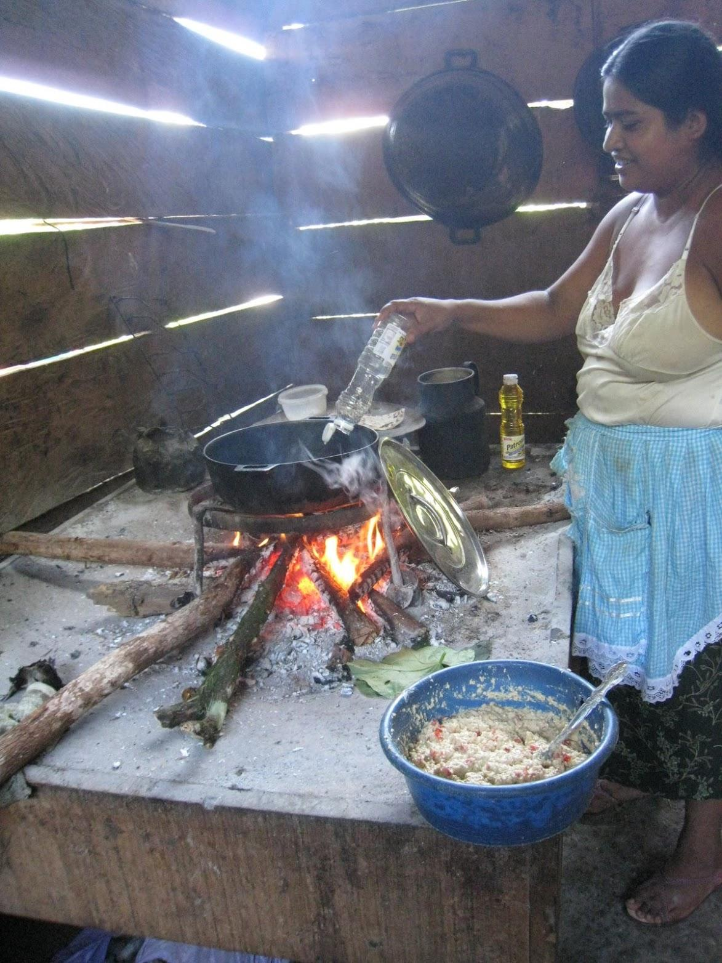
Take a minute to analyze the following image you might find on a friend's Instagram. Write a brief description of the first things that come to mind. What do you see?
My first thoughts are, what a simple way of life. She looks perfectly content.

Now imagine that the image had been accompanied by the following caption:
Olivia, the President of the women's committee in Samox San Lucas, Guatemala, welcomed our student team to the community with a delicious meal. She taught us how to make tortillas then her kids took us out to the field to show us where the corn in the tortillas was grown.
How does the caption shape what you see in the photograph? In the short answer box, write a reflection about the role that the context plays in the way that the photograph is interpreted. Note the assumptions you made that shaped your interpretation of the caption-less image.

PM-1 Crafting an Opportunity Statement
Start to practice writing some problem or opportunity statements. Think about a project you are working on currently; it could be a community based project, or it could be a project that you have to do for work or for school. Ask yourself, what is the challenge at hand? Conversely, what is the opportunity that we are trying to take advantage of?
Here is an example of how to narrow an opportunity/problem statement examples for you to consider:
First draft: The City of Fairview seeks to decrease the amount of trash in its alleys.
This statement does not get into why this is a problem or opportunity for the city or the citizens. Ask yourself, “Why is this a problem?”, as a method to narrow or specify the statement. You can use the iterative interrogative technique of the Five Whys as a way to find out the reason that the problem is important for you or for your partner organization.
Second draft: Because there is a large number of feral cats in the City of Fairview, the City seeks to decrease the amount of trash in its alleys; the trash draws feral cats to the area to live.
Now, let’s ask the question of why is this problem important?
Final version: The City of Fairview wants to make its downtown area a more enjoyable place for citizens to visit. Because of how trash is collected in alleys, there is an abundance of feral cats roaming the streets that deter citizens from visiting downtown.
Write out one to three examples of opportunity/problem statements that are related to projects that you are currently working on. Consider writing the same problem statement multiple times asking yourself, “why?”, to help determine what is driving your engagement.
The overall goal from the office of head start is for the grantee, CCA, to provide 20% of the federal grant in volunteer hours (in kind). In order to successfully meet those goals, we need to focus on the bottom three performer campuses, and implement ways to increase the engagement and volunteerism and ensure we do not lose the grant and are still able to provide services to these communities.

PM-2 Developing Objectives

In the space below, write your objective(s) for your upcoming community project or for a project that you have already completed. Check to ensure that your objective(s) are clearly related to your problem/opportunity statement, and that all elements of SMART goals are included.
Learn more about writing objectives.

PM-3 Identifying Deliverables
The three main components of a project management charter are the opportunity statement, objectives, and the deliverables. The opportunity statement states what the issue is, the objectives state the SMART goals of the project will be, and the deliverables are the tangible or intangible products that ensure that the outcomes happen.
See our three examples pulled together, and how they are associated with each other:
Opportunity statement: The City of Fairview wants to make its downtown area a more enjoyable place for citizens to visit. Because of how trash is collected in alleys, there is an abundance of feral cats roaming the streets that deter citizens from visiting downtown.
Objectives: Within one year of April 2018, the City of Fairview will no longer have feral cats in the downtown area.
Deliverables:
- A comparative analysis report on how peer (size, geography, desired downtown citizen engagement) three cities store and remove trash in their downtown areas
- A research report on best practices for rehousing feral cat populations
- A research report on citizens in the City of Fairview and their perceptions around engagement in the downtown area
- A recommendation report on next steps for increasing citizen engagement in the downtown area of the City of Fairview
View the first version of a Project Scoping Document from a student project. (note that names and other identifying details have been changed.)

Write deliverables for your project. Deliverables should be high-level action items that move the project forward.

Share all three components of your charter document to the discussion board.

PM-4 Stakeholder Discovery
After reading through the key questions for identifying stakeholders, think of your own community project or a project you have already completed. In your workbook, brainstorm a list of possible stakeholders. Using your list, work backwards and identify three to four primary stakeholders and one to two secondary stakeholders, and if possible one tertiary stakeholder. These are the people or organizations that you should check in with intermittently throughout your project to ensure that their needs and concerns are being met. Take a look at the following list to get your brainstorming started. Later, you’ll return to this exercise in which you list these out more intentionally.

PM-5 Stakeholder Discovery II: Identifying Stakeholders
Return to the list of stakeholders you brainstormed in the previous activity. Using the list below, try to generate an even bigger and broader list of stakeholders for that same project. Think broadly, attempting to come up with at least ten different stakeholders. Then divide the stakeholders into three categories, grouping your stakeholders by primary, secondary and tertiary levels.

- Team members
- Community partners
- Beneficiaries of the project (students, patients, customers, etc.)
- Suppliers (gatekeepers of resources)
- Regulators (police, legal departments, etc.)
- Competitors
- Funders
- Local residents
- Other community organizations
- Family of beneficiaries

PM-6 Specifying Exclusions & Assumptions
create a list of 3-5 assumptions that you are making about the conditions for your project. You might use the same project you reflected on for the previous activity, or another.

PM-7 Managing Time
What are the major milestones for your project? In the space below, create a list of 3-5 major milestones for your own project. Include an estimate of how long you anticipate each task to take. Based off of these milestones, how long do you expect the entire project to last?

PM-8 Ensuring Sustainability
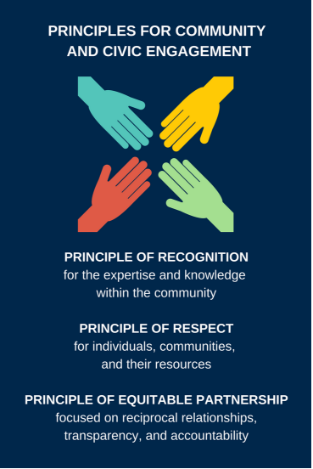
How does building time and working toward sustainability relate to Principles of Civic and Community Engagement we have discussed throughout this course?
- How does the Principle of Recognition factor into sustainability? Why do you need to recognize the expertise and knowledge within the community to create a sustainable project? What might ignoring community expertise and knowledge do to your project?
- How does the Principle of Respect factor into sustainability? How does building a sustainable project require and foster respect for individuals, communities, and their resources?
- How does the Principle of Equitable Partnership factor into sustainability? How might reciprocity, transparency, and accountability contribute to a sustainable outcome?

C-1 Parting Insights

As you watch the video of advice from community partners, use the outline below to jot down the most important takeaways on the three key themes. Then after you’ve finished watching, take a few minutes to reflect on your own experiences, hopes, and concerns, and note if anything stands out to you.
Preparation
- Takeaways
- What new ideas and strategies do you have for preparation?
- What is one concrete thing you will do to prepare for your experience?

Communication
- Takeaways
- What new ideas and strategies do you have about communicating in the context of community engagement?
- What is one concrete thing you will do to communicate effectively during your experience?

Fostering Relationships
- Takeaways
- What new ideas and strategies do you have about fostering relationships in the context of community engagement?
- What is one concrete tool or strategy you will use when building relationships during your experience?
C-2 Integrative Reflection

If you took Module 4: Reflections and Transitions, you learned about the importance of ongoing reflection. As a capstone activity, here’s an opportunity to reflect on your work in the whole course to solidify your learning and consider how to apply it in your own community engagement.
In the four quadrants below, write a few sentences that respond to the following prompts:
- What are two or three of the most important things you’ve learned?
- So what? Why do those things matter in the context of your own community engagement work?
- Specifically, now what steps will you take to apply those things in your context?
- What else: what are one or two questions you still have or topics you want to explore further?
In addition to helping you think through what you’ve learned in this course and how you might apply it, this is a transferable framework that you can reuse any time you need to reflect on an interaction, a challenge, a success, or any experience. Keep this framework in your toolbox and use it anytime you need to reflect.
What are two or three of the most important things you’ve learned? | So what? Why do those things matter in the context of your own community engagement work?
What else: what are one or two questions you still have or topics you want to explore further? | Specifically, now what steps will you take to apply those things in your context?

This activity has been adapted from Safe Zone Project. "Privilege for Sale 2.0," Safe Zone Project, http://thesafezoneproject.com/activity/privilege-for-sale-2-0/ (March 27, 2018). Other resources referenced include Peggy McIntosh, "White Privilege: Unpacking the Invisible Knapsack," Peace and Freedom Magazine, July/August, 1989, pp. 10-12.
This list is lightly adapted from The Program on Intergroup Relations, "Social Identity Groups," (Handout), Diverse and Inclusive Teaching Workshop, March 17, 2017, at University of Michigan, Ann Arbor, Michigan).
This activity is adapted from Holly Epstein Ojalvo, "Who’s Got the Power? Reflecting on Healthy and Abusive Relationship Dynamics," New York Times, February 14, 2012, https://learning.blogs.nytimes.com/2012/02/14/whos-got-the-power-reflecting-on-healthy-and-abusive-relationship-dynamics/
This activity has been adapted from Safe Zone Project. "Privilege for Sale 2.0," Safe Zone Project, http://thesafezoneproject.com/activity/privilege-for-sale-2-0/ (March 27, 2018). Other resources referenced include Peggy McIntosh, "White Privilege: Unpacking the Invisible Knapsack," Peace and Freedom Magazine, July/August, 1989, pp. 10-12.

